Balancing Accruals in Finance and HR
For LEAs that Accrue Monthly

Presented by ESC, Region 14

August, 2020

This procedure will help ensure that monthly accruals are booked accurately and consistently in both HR and Finance. It is critical that areas agree so that accurate reporting can be made on Federal Funds and so district personnel feel confident about the state of their books. To that end, we recommend that you balance your accruals as part of the End of Month Finance Procedure. By completing this monthly, errors can be quickly identified and more easily resolved.

Note: Screen shots may display data from previous years. They are provided as examples only. The processes outline remains the same.

- In Finance > Tables > District Finance Options > Clearing Fund Maintenance tab. Print the table. This can be used each month as changes are rarely made to the table during the year.

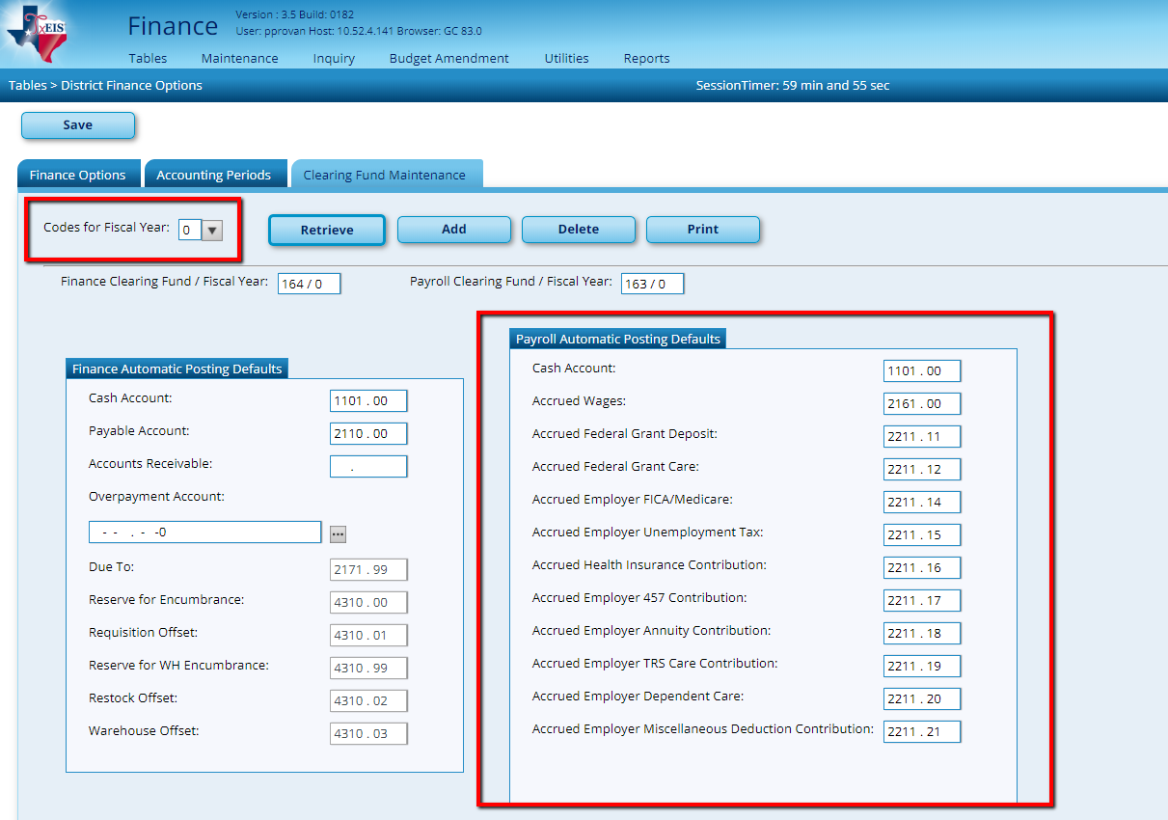
Your Object code may be 2210.XX instead of 2211.XX as shown.

- In Finance > Inquiry > General Ledger Inquiry > GL Acct Summary tab.
  - Print the inquiry for object code 216X (Accrued Wages.)

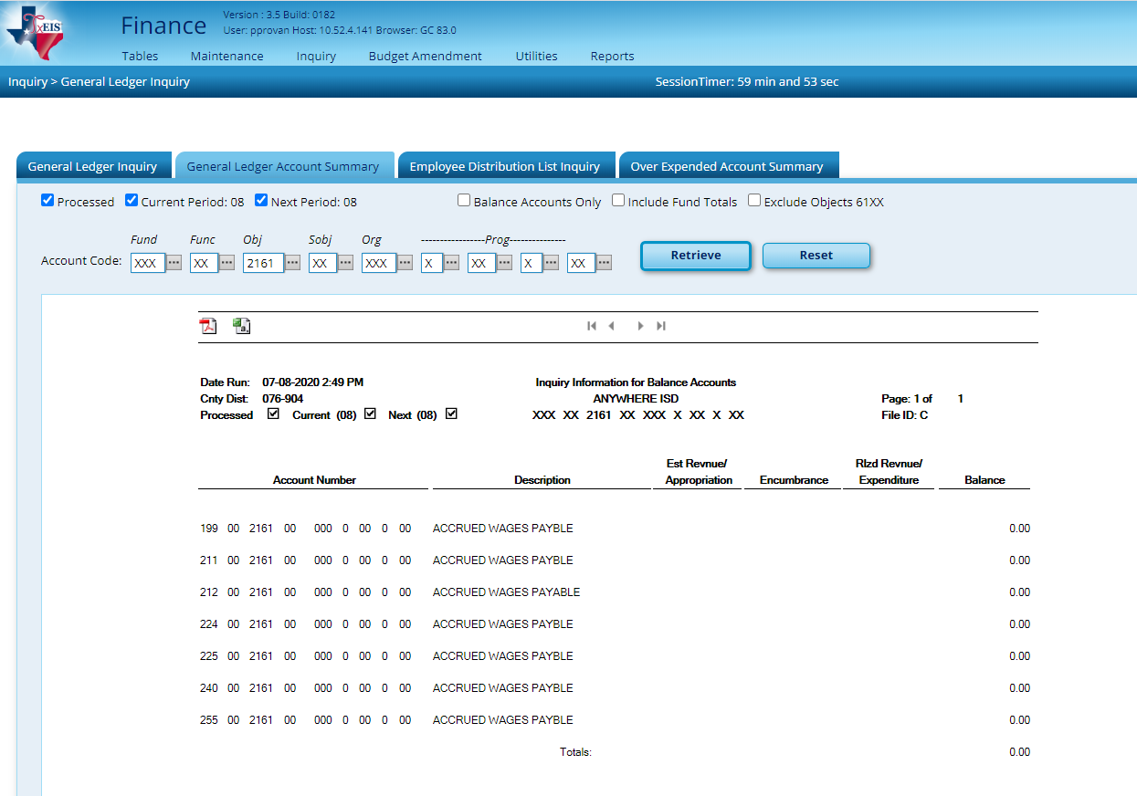

- While in this same area, print the report for object code 221X and each sub-object reflected in the Clearing Fund Maintenance table printed in step 1 (Accrued Benefits.) We recommend printing each sub obj separately to simplify balancing. (Our screen shot shows multiple sub objects simply to save space).

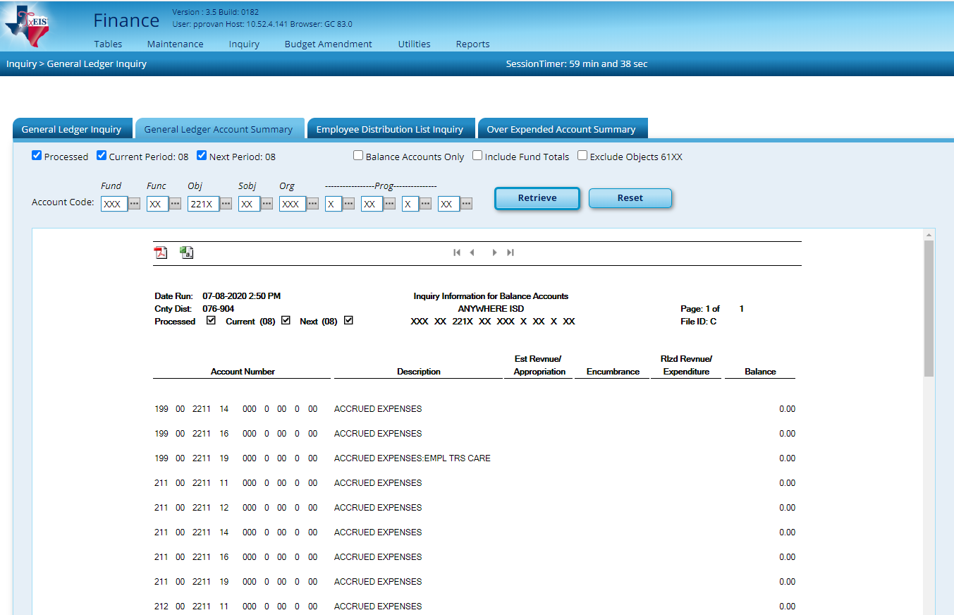

- In Human Resources > Reports > HR Reports > Year to Date Reports > School Year to Date Report (HRS 3050).
- Sort by Alpha (A),
- Enter the school year (2020) and
- Select an (N) to NOT include Job Accrual Detail(s).
- Print only the last page of the report.

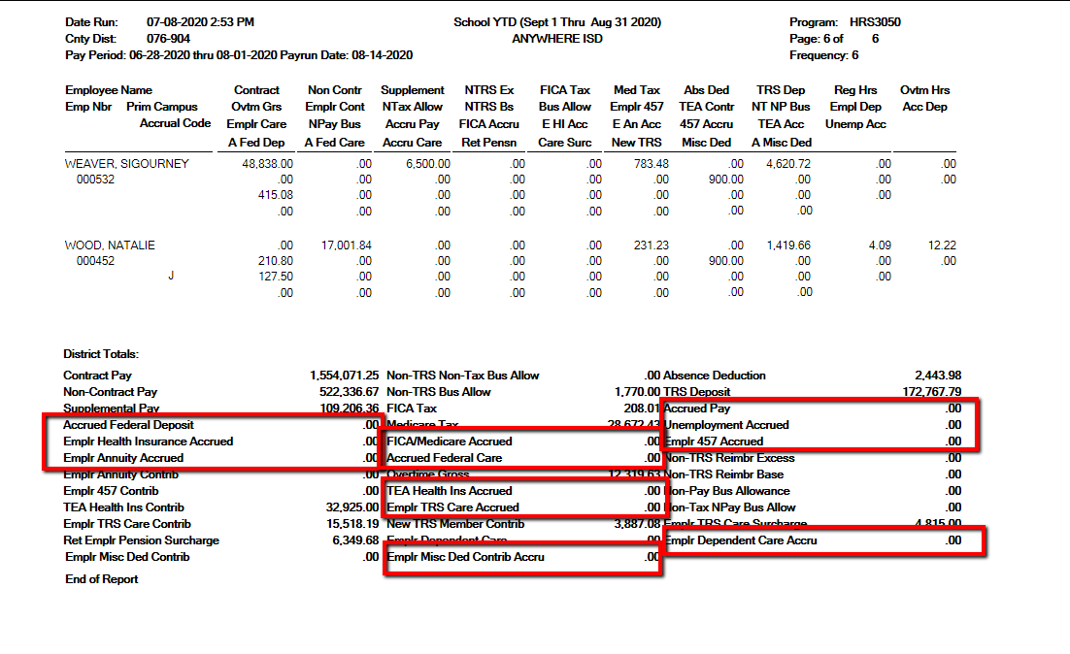
(1)
(15)
(17)
(20)

(21)
(14)
(12)

(16)
(19)

(11)
(16)
(18)

(20)

(16)
(19)

(14)
(12)

(21)
(20)
(21)

(1)
(15)
(17)

(14)
(12)

(16)
(19)
(11)
(16)
(18)

Note: Numbers in Red are the Sub-object’s that will be compared to the General Ledger Inquiry Report on the next page.

- Compare the totals in the General Ledger Inquiry reports to the totals on HRS 3050 as shown below:

General Ledger Inquiry Report | School YTD Report | Expenditure Object Code
216X | Accrued Pay | 6119 or 6129
2211.11 | Accrued Federal Deposit | 6146
2211.12 | Accrued Federal Care | 6146
2211.14 | FICA/Medicare Accrued | 6141
2211.15 | Unemployment Accrued | 6145
2211.16 | Emplr Health Insurance Accrued +  TEA Health Ins Accrued | 6146
2211.17 | Emplr 457 Accrued | 6149
2211.18 | Emplr Annuity Accrued | 6149
2211.19 | Emplr TRS Care Accrued | 6146
2211.20 | Emplr Dependent Care Accrued | 6149
2211.21 | Emplr Misc Ded Contrib Accrued | 6149

Assuming you accrue only your 10 month employees, balancing after you have completed August payroll, but before running the August Accrual process can be the easiest time to complete this process. The amounts shown on the School Year to Date Report and on your General Ledger Inquiry liability accounts (216X and 221X.XX) are typically all zeros at this time. However, there are 5 possible scenarios to consider.

Scenario | School YTD Accrued Amounts | Finance Gen Led Accrued Liabilities | Action Needed
1 | Zeros | Zeros | None needed
2 | Show amounts | Zeros | Zero SYTD Utility > Post to Master Only
3 | Zeros | Show balances | Manual Entries in Finance Only
4 | Show Amounts that match GL | Show Amounts that match SYTD | Zero SYTD Utility > Post to Master & Interface to Finance
5 | Show Amounts but DO NOT match GL | Show Amounts but DO NOT match SYTD | Zero SYTD Utility > Post to Master, Consider Interface to Finance, plus Manual Entries in Finance

Please identify the scenario that matches your situation and complete the steps indicated for that scenario. Details follow. Please be aware that we have collected examples over the years so fiscal years, amounts and screenshots may look different. The processes should be the same though, making this a helpful resource.

Scenario 1

The School YTD report shows zeros for Accrued totals and the liability accounts in Finance are zero. There is no action required for this scenario. If all goes perfectly during the school year, this is the anticipated result.

Scenario 2

The School YTD report shows amounts for Accrued totals but the liability accounts in Finance are zero.
Use the Zero School YTD Utility in Human Resources to zero the amounts in HR. Post to Master in the Utility but DO NOT Interface to Finance.
Human Resources > Current Payroll Frequency > Utilities >
Zero School YTD Accruals

On the Extract tab
1. Verify School Year as 2020
2. Retrieve
3. Enter JV # ZEROAC.
4. Verify File ID C
5. The left window displays any employees whose School YTD accruals were not cleared during payoff. Move employees from the Left to the Right.
- Run

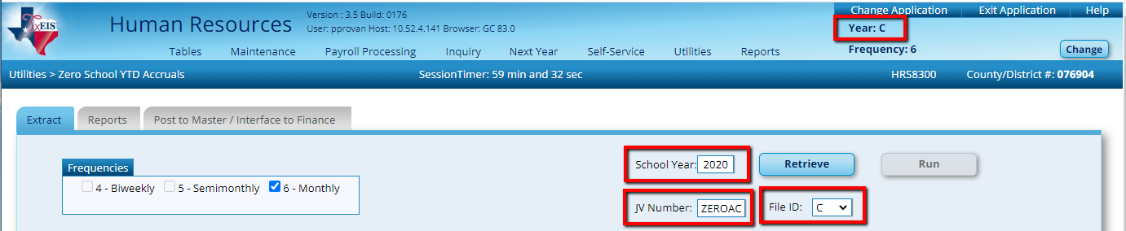

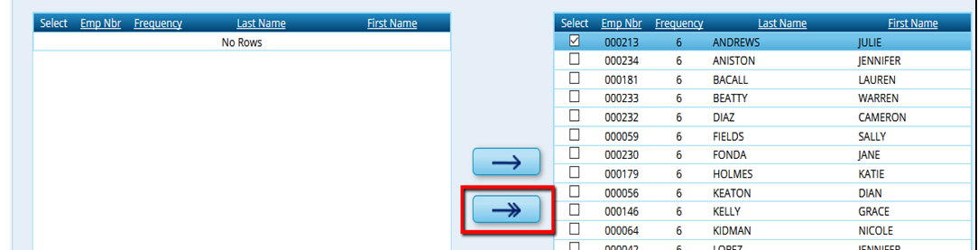

If the procedure ran successfully then Close the Extract report.

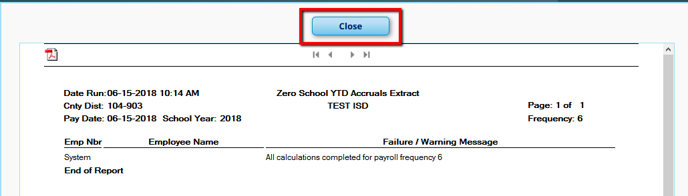

On the Reports tab, generate and save reports as desired.

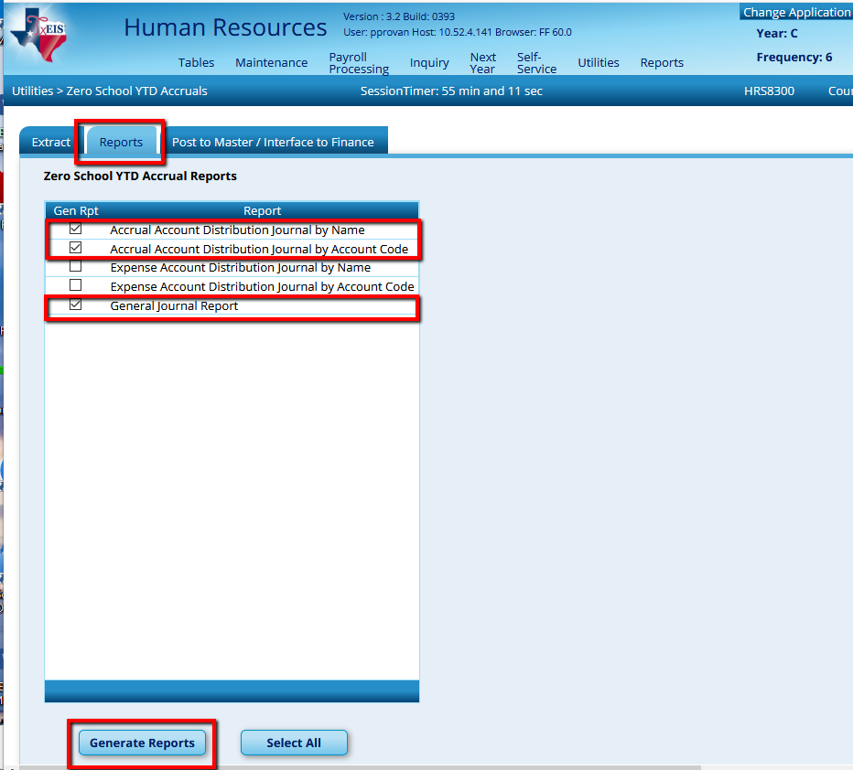

On the Post to Master / Interface to Finance tab, choose to Post to Master and click Post.

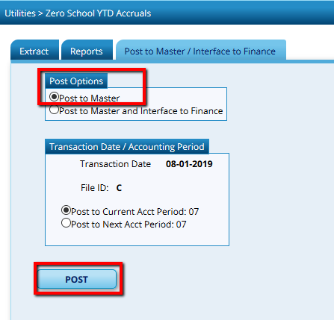

Scenario 3

The School YTD report shows zeros for Accrued totals but the liability accounts in Finance have balances.
A JV will need to be entered to zero out the liabilities from Finance > Postings > Journal Actual tab. Refer to the chart on page 5 of this document to see the expenditure object that ties to each liability. As an example, if the Accrued FICA/Medicare liability line (object 221X.14) shows a balance of -$158.56, you will need to hit a payroll expenditure account with an object code of 6141.
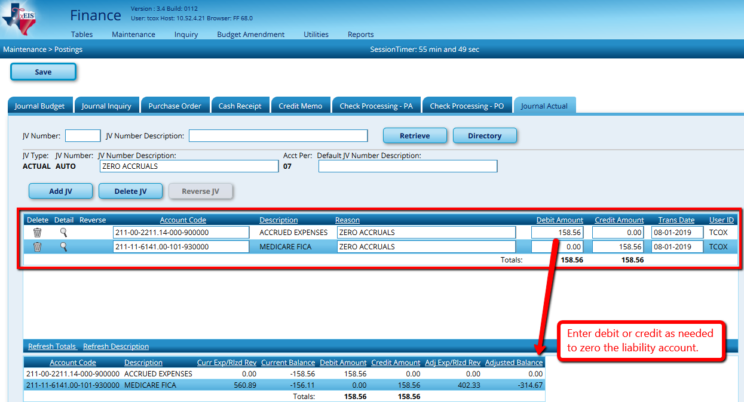

Scenario 4

The School YTD report shows amounts for Accrued totals and the liability accounts in Finance show matching amounts.
Use the Zero School YTD Utility in Human Resources to zero the amounts in HR and to Interface to Finance so that both are zeroed at the same time.
Human Resources > Current Payroll Frequency > Utilities >
Zero School YTD Accruals

On the Extract tab
1. Verify School Year as 2020
2. Retrieve
3. Enter JV # ZEROAC.
4. Verify File ID C
5. The left window displays any employees whose School YTD accruals were not cleared during payoff. Move employees from the Left to the Right.
- Run

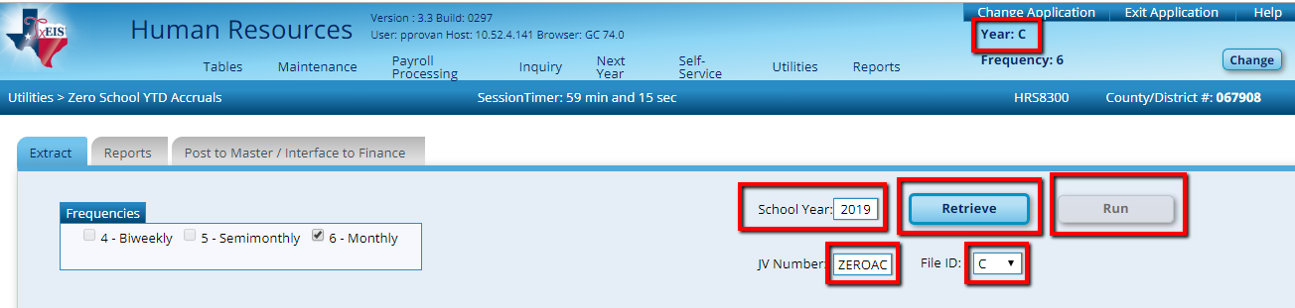

If the procedure ran successfully then Close the Extract report.

On the Reports tab, generate and save reports as desired.

On the Post to Master / Interface to Finance tab, choose to Post to Master and Interface to Finance, enter a Transaction date and choose the desired Accounting Period. Click Post.

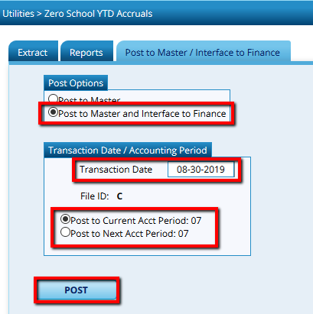

Scenario 5

The School YTD report shows amounts for Accrued totals and the liability accounts in Finance show amounts, but the amounts do not match.
Use the Zero School YTD Utility in Human Resources to zero the amounts in HR. Consider whether Interfacing to Finance will decrease or eliminate some of the liability balances in Finance. If so, choose to Interface. If it will make the differences greater, choose to Post to Master only.
Human Resources > Current Payroll Frequency > Utilities >
Zero School YTD Accruals

On the Extract tab
1. Verify School Year as 2020
2. Retrieve
3. Enter JV # ZEROAC.
4. Verify File ID C
5. The left window displays any employees whose School YTD accruals were not cleared during payoff. Move employees from the Left to the Right.
- Run

If the procedure ran successfully then Close the Extract report.

On the Reports tab, generate and save reports as desired.

On the Post to Master / Interface to Finance tab, choose to Post to Master or Post to Master and Interface to Finance as desired. If choosing to Interface, enter a Transaction date and choose the desired Accounting Period. Click Post.

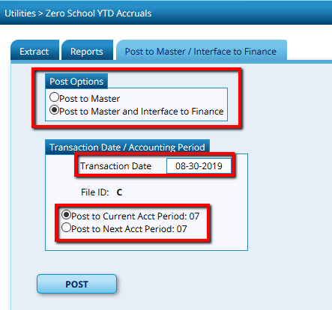
If Interfacing, select a Transaction Date and Accounting Period.
Choose whether you want to Post only, or Post and Interface

